Disclosure Documents
City of Dublin
Parcels
273-000068, 273-000107, 273-000032
Point of Contact: Sarah Holt
Senior Planner, sholt@dublin.oh.us

Table of Contents

Property History 2
Individual Property Condition Assessments 3
Rehabilitation/Renovation/Redevelopment Goals 4
Reserve Prices 5
Existing Easement 5
Zoning and Uses 5
Property Maintenance and Rehabilitation Requirements and Timeline 5
Deed Restriction 6
Historic Walls 6
City Improvements 7

Appendix Documents:
A – Historical and Cultural Assessments
B – CTL Report
C – 2022 Annual Letter
D – Riverview Village Proposal
E – Recorded Easement
F - Code Enforcement List of Deficiencies
G – Historic Stone Walls
H – Riverside Crossing Park Master Plan

Property History
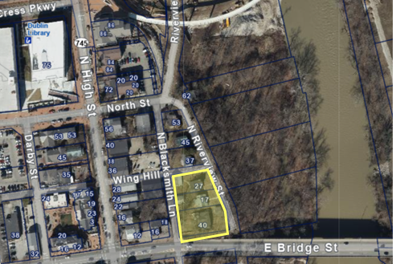
The properties (“Properties”) are located on North Riverview Street, just south of Wing Hill Lane and north of East Bridge Street. All Properties face North Riverview Street, and two have access from North Blacksmith Lane, an alley.
The homes were constructed between ca. 1850 and 1927. They each represent a sampling of the different styles of homes constructed during that period. Commonalities of construction utilized for each property are stone basements, wood frame construction, either shingle or metal standing seam roofs, and single-pane windows. The exterior and interior materials are a mix of original and replacement and are in various states of repair. Some historic interior elements are missing.
All of the Properties are recommended contributing to the Dublin Historic District by the 2017 Historic and Cultural Assessment. Contributing structures are those that add to the historic integrity or architectural quality of a historic district. As a result, these Properties come under the purview of the Architectural Review Board, which approves all changes in the Historic District. See the Historical and Cultural Assessment Report on the individual properties in Appendix A.
As part of the City’s purchase of these Properties, CTL Engineering, Inc. was hired to perform a Property Condition Assessment (PCA) for all properties. These were completed on December 10 and 11, 2020. The Properties were assessed individually to determine the general condition of each: the exterior building envelope (siding, roof, doors, and windows); interior spaces (floors, walls, ceilings, doors, plumbing fixtures, and casework); mechanical/electrical/plumbing (MEP) systems; and an environmental survey checked for the presence of Hazardous Containing Materials (HCM). These assessments were performed on the main residences as well as the outbuildings.
In summary, the overall general condition of the Properties ranged between fair (two properties) and good (one property). All of the properties were found to have HCM present in the form of asbestos-containing materials and lead-based paint. All of the properties need electrical, mechanical, and plumbing work to bring them up to code. Most of the roofs are in fair to poor condition and in need of replacement. Some roofs need immediate attention, and there are structural issues for the first floor of some homes where the floor joists are damaged due to dry rot and stress over decades of use. Some of the homes also need the siding replaced and masonry tuck-pointed.
A summary of the individual conditions of each property is below, while photos of the Properties and detailed PCAs from CTL are in the Appendix B.

Individual Property Condition Assessments

17 North Riverview Street
This structure is a 1.5-story, Craftsman-style, single-family house resting on a concrete block foundation. West of the house is a detached garage. The interior wood finishes are mostly original and in good condition. Most of the interior doors are original and have been well-maintained. The newer finishes and upgrades to the kitchen and bathroom are complementary to the original home.
This property has a barn at the rear that appears to have been moved to the site, as the interior structural columns are not original to the building. The property has a newer standing seam metal roof.

27 North Riverview Street
This structure is a two-story, gabled ell-style, single-family house resting on a stone foundation. There is a large carriage barn west of the house. This home appears to be the most historically accurate, in terms of the original construction. The interior of the home has much of the original wood finishes and details, and these are distinctively higher-style than the other homes. Some modernization has occurred in the kitchen and living room, where the fireplace masonry and hearth are all of a newer style. A fiber-type ceiling, adhered with mastic to what is likely the original ceiling, is in one of the rooms.
The carriage barn is in poor condition and has a sagging ridge. There are signs of rotted wood clapboard siding next to the foundation.

40 East Bridge Street (AKA 7 North Riverview Street)
This property contains a two-story, vernacular-style, single-family house resting on a stone foundation. The roof is in poor condition and needs replaced. The interior is a mix of original wood flooring, replacement vinyl flooring, and 12”x12” glazed tile. There is a new kitchen and an upgraded bathroom. The stairs have been modernized and the ceilings have been refinished with textured drywall. Water damage is visible in several locations. For the most part, the original historic interior details no longer exist.

Rehabilitation/Renovation/Redevelopment Goals
When the City issued a Request for Proposal the intent was to solicit proposals that achieved the following goals:

    - Preserve the historic nature and mass of North Riverview Street;
    - Rehabilitate/renovate/redevelop the Properties, which have fallen into disrepair, so that they can contribute to the beauty of Historic Dublin;
    - Enhance the neighborhood while respecting the historic character of early Dublin and the Properties themselves;
    - Encourage uses that create visitor interest, experiential vibrancy, and pedestrian engagement;
    - Demolition would require Architectural Review Board (ARB) approval;
    - Provide the vision, experience, and financial commitment to renovate the Properties in a timely manner;
    - Preserve Dublin’s signature historic stone walls on each applicable property; and
    - Document historic details and cultural resources prior to any demolition or removal.

The City’s intent, even through the disposal of these Properties, is still to achieve these goals. Historic Dublin Property Owners play an important role in keeping the character of Dublin intact for both current and future residents. It is so important that the City mails an annual letter to property owners providing resources to City Code, Design Guidelines and an ARB Application. See Appendix C for the 2022 Annual Letter.

Riverview Village Proposal
In April 2022, the City of Dublin advertised a Request for Proposal for seven residential lots and two parcels on N. Riverview Street. Two responses were received, and City Council approved the Advisory Committee’s recommendation to direct staff to further evaluate and negotiate Community Space Development, LLC’s (CSD) proposal for a potential Economic Development Agreement. As part of the proposal, the three southernmost properties were identified as an option for others to own and renovate. Consistent with City Council’s direction, negotiations are on-going and working towards a Development Agreement. Please see the Appendix D for the full Proposal.

Reserve Prices

Minimum reserve prices for each of the Properties are listed below to recoup all costs incurred by the City.
- 17 N. Riverview Street – $292,356
- 27 N. Riverview Street – $321,057
- 40 E. Bridge St (AKA 7 N. Riverview Street) – $418,385

Existing Easement

An exclusive perpetual easement for public highway and road purposes, including, but not limited to pedestrian facilities, public and private utilities, storm drainage facilities and grading purposes exist on each property. See Appendix E for the Recorded Easement with Franklin County.

Zoning and Uses

The Properties are zoned Historic District – Historic Residential. Full zoning information is contained within the Historic District Code, and can be found at https://dublinohiousa.gov/dev/dev/wp-content/uploads/2012/05/FINAL_Historic- Zoning-Code-Formatting.pdf and should be consulted for all requirements. The Historic Design Guidelines also apply to these properties, and they can be found at https://dublinohiousa.gov/dev/dev/wp-content/uploads/2021/11/HDG_Version_Sept- 2021_FINAL.pdf and should be consulted for more important information.

Property Maintenance and Rehabilitation Requirements and Timeline

In July 2023, each property was given a ground-level, exterior-only inspection to determine applicable Property Maintenance Code violations, as defined in IMPC 2021, and enforced by City Code. Nuisance issues such as grass and weeds, trash and debris, and unsightly conditions were not included in this assessment. Each address’ violations are itemized in Appendix F, which will need to be addressed in the timeline outlined below.
- 30 days from closing
  - Meet with staff to discuss outstanding property maintenance items, review Code and Guideline requirements for rehabilitation and begin the Architectural Review Board (ARB) process.
  - Intent is to maintain consistent minimum timeframes to work toward property maintenance compliance while allowing the winning bidders to develop conceptual ideas for their property.
- 90 days from closing
  - Maintenance work, replacing like-for-like materials, as determined by staff, could reasonably be expected.
  - Submittal of a development application to the ARB for rehabilitation work, consistent with the Historic District Code and Historic Design Guidelines.
- 6 weeks from application submittal
  - Determination by the ARB could be expected 6 weeks from complete application submission.
- Post ARB approval –
  - Building permit submission and approvals required prior to construction

Deed Restriction

The Properties shall not be combined with any other parcel.

Historic Walls

All Historic Stone Walls must be preserved, unless modifications approved by the City. A map noting the walls is below. Additional information on the stone walls can be found in Appendix G.
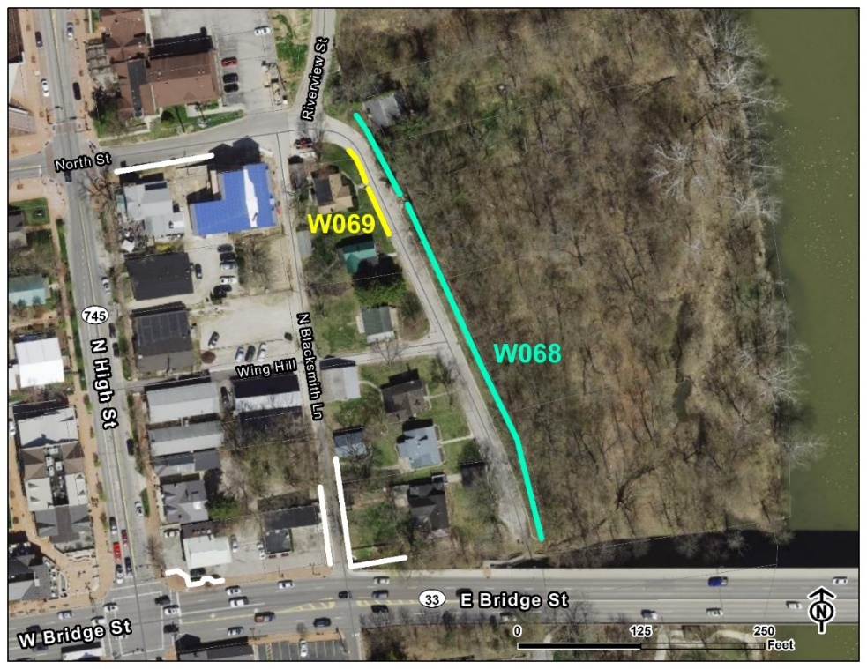

City Improvements

There will be several City improvements in the adjacent area to disclose. One project already in the five-year Capital Improvements Program includes Riverside Crossing Park to include trails and additional improvements, https://city-dublin-oh-budget-book.cleargov.com/4817/capital-request/35594/view, see Appendix H for the Master Plan.

Other projects not currently programmed in the five-year Capital Improvements Program but on the horizon include but are not limited to road improvements to N Blacksmith Lane, and North Street at N. Riverview Street.

APPENDIX A – Historical and Cultural Assessments

APPENDIX B – CTL Report

APPENDIX C – 2022 Annual Letter

APPENDIX D – Riverview Village Proposal

APPENDIX E – Recorded Easement

APPENDIX F – Code Enforcement List of Deficiencies

APPENDIX G – Historic Stone Walls

APPENDIX H – Riverside Crossing Park Master Plan

