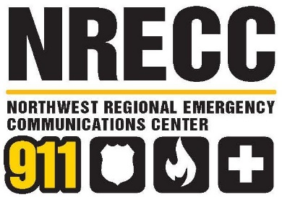
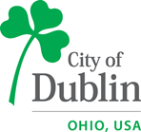

DUBLIN POLICE DEPARTMENT
2026 GOALS AND OBJECTIVES

Mission Statement & Core Values

Dublin Police employees are committed to protecting life, liberty and property. We will provide the highest level of service and work in partnership with our community to ensure public safety by focusing on the following core principles;

• Vigilant, Ethical and Impartial Enforcement of Law
• Critical Incident Preparedness and Response
• Crime Prevention, Reduction and Deterrence
• Improvement of Traffic Safety
- Community Outreach and Engagement

We will remain dedicated to service and committed to excellence, focusing on the following core values:

Professionalism

We are members of an exceptional and highly trained law enforcement organization. Our conduct and demeanor adhere to the highest standards of personal and organizational excellence.

Integrity

We hold ourselves accountable to the highest level of honesty, truthfulness, and ethical conduct.

Respect

We ensure that all persons are treated with equality, dignity and courtesy.
Commitment
We are dedicated to our Profession, our Community, our Agency and
our Mission.

2026 Goals & Strategies

1 | Deliver fast, accurate, and compliant emergency call handling by consistently providing timely responses, maintaining high-quality call processing standards, and ensuring full adherence to Ohio PSAP Operating Rules through ongoing training and protocol improvement.

- Continue to improve average call answer time to meet or exceed national standards (e.g., 90% of calls answered within 10 seconds).
- Prioritize accuracy and efficiency in call processing – use resources available to confirm location, caller information, responder safety information and expedite service dispatching.
- Monitor need for protocol updates and training through routine quality assurance reviews.
- Compliance with Ohio PSAP Operating Rules.
2 | Fully implement and operationalize its upgraded technology infrastructure.

- Complete Eventide recorder installation; complete supervisor training on QA component.
- Finalize CAD/RMS vendor selection and begin implementation.
- Conduct regular testing and maintenance of all critical systems to minimize potential downtime. Report any issues in a timely manner.
3 | Complete recruiting and hiring processes to fill vacant positions and new authorized positions.

- Engage with community groups, schools, and local organizations to promote understanding of 9-1-1 services and public safety communications as a career option.
- Hire and train new authorized staff to support call volume and reduce mandatory overtime.
- Provide staff with ongoing training in areas such as crisis intervention, mental health response, and emerging technologies.
- Identify training opportunities and succession planning programs for leadership and specialized positions.
- Hire and train Communications Supervisors and CAD Manager.
4 | Implement a structured Quality Assurance and Performance Improvement program.
- Provide quality assurance (QA) reviews to include quarterly and critical incident call reviews, feedback, and coaching.
- Consistent review of performance data and analytics to identify trends, training needs, and continuous improvement opportunities.
5 | Strengthen interagency coordination and operational effectiveness by enhancing collaboration, standardizing policies and services, and improving information sharing and joint training with partner and responding agencies.
- Regularly scheduled meetings with partner agency liaisons for policy review, standardization of services and potential training needs.
- Improve information sharing and joint training exercises with responding agencies.

