Dear Resident

The City of Dublin is constantly working to improve the quality of our streets and other infrastructure. In our community surveys, respondents consistently list roadwork and traffic improvement as their top goals for Dublin. This year, your street has been selected as one of the streets to be resurfaced or reconstructed. This flyer is designed to help inform and prepare you for the process.

During resurfacing, you can expect any of the following actions:
- Removal of all or part of the existing asphalt surface
- Replacement of deteriorated curbs
- Repair of storm drainage inlets
- Replacement of existing asphalt pavement with a new asphalt surface
- Restoration of tree lawns behind the new curb with topsoil and seeding
- Restoration of driveway aprons as required by grade changes in the curb line to correct drainage issues
- Installation of new ADA access where existing sidewalk ramps are deficient at street intersections

If you have any concerns throughout the process, please contact Doug Fleck at 614.410.4668 or dfleck@dublin.oh.us. We will be working diligently to restore your street as quickly as possible.

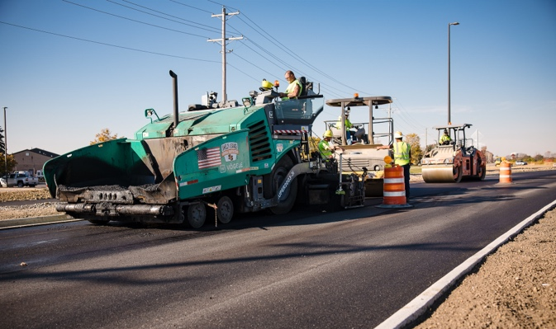2026 street maintenance
The Street Maintenance Program is scheduled to begin in May and continue through October. The contractor will be working in numerous areas throughout Dublin. Advisory signs will be posted in your neighborhood to announce the start date for work in your area about a week before work begins. Project updates will be available on the City of Dublin website at
DublinOhioUSA.gov/street-maintenance-program and on Nextdoor.com.

When will the work take place?
Construction hours are generally 7 a.m. to 6 p.m. You will have access to your driveway majority of the time. If a new curb is installed in front of your driveway, you will not have access to your driveway for up to seven days. You will receive advanced notice of this work via door hanger.

Please minimize on-street parking in the work zone when possible. On-street parking will be available outside of the work limits.

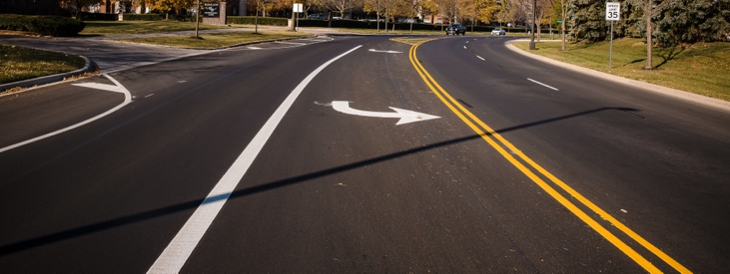

What happens during construction?
There are multiple stages in resurfacing or reconstructing a street. You will notice equipment such as backhoes, concrete saws and dump trucks hauling construction materials. Some days, there will be a lot of activity; other days, very little. In general, these are the steps of the street maintenance process:
- Marking/layout for proposed improvements
- Curb & gutter removal and replacement
- Sidewalk and ramp replacement
- Asphalt roadway work
- Lawn restoration
- Pavement sealing (rejuvenation) and striping
- Road is complete and ready for use

How will I be affected during construction?
Access to your street and, sometimes, your driveway may be obstructed during construction hours. Some streets may be closed to through traffic. We do not plan to disturb private property. However, if any damage does occur to your lawn, it will be repaired. The City appreciates the property owner’s cooperation in watering newly seeded areas. Please notify your lawn services of any seeded areas on your property.

Your mailbox may be temporarily removed during this process. Temporary mailboxes will be placed during the project to allow uninterrupted mail delivery. Once the improvements are made, your mailbox will be permanently reset in its original location in the same or better condition than when the project began.

Is there anything the property owner will be responsible for?
The existing downspout drain tile from the house that connects to the curb has often settled over time. This becomes visible once the curb is removed. The City will reconnect the existing drain tile through the new curb. Elevation adjustments due to the existing drain tile being low are the property owner’s responsibility.

What if I have a sprinkler system or underground dog fence?
If either is immediately behind the curb, please notify Doug Fleck at 614.410.4668 or dfleck@dublin.oh.us as soon as possible. Please mark the irrigation system or dog fence with marking paint or flags before construction activities (once you see notification signage posted in your area). The contractor will be notified to use caution during curb removal or other work in the vicinity. Should the contractor damage your sprinkler system or dog fence after the City is notified and the irrigation system or dog fence is marked as requested, the contractor will repair it to its original condition as soon as possible. Once construction begins in front of your house, please test your dog fence before you let your dog out.

What has the City done to keep debris and noise to a minimum?
Construction projects create noise, dust and other disruptions. The City has restricted construction hours to 7 a.m. to 6 p.m. The contractor will work to minimize dust, clean up debris regularly and fix any damage. Thank you for your patience.

Will this impact other City services?
There will be no changes in your emergency services. The police and fire departments will be notified of all traffic restrictions. All lawn waste, garbage and recyclable collection should continue according to their regular pick-up schedules unless you are advised otherwise.

For more information or to submit a repair request or service follow-up, please visit GoDublin at DublinOhioUSA.gov/godublin/

