March 9, 2020
From: Steven M. Roberts, Architect

To: Nichole Martin, Planner
5800 Shier-Rings Road
Dublin, Ohio 43016

Re: TownePlace Suites – Exterior Vents & Louvers
Address: 5155 Upper Metro Place
Application No.: 18-20388
We would like to formally request a waiver from the Planning and Zoning Commission that the following vents and louvers be permitted on “street facing” facades for the above referenced project.
The vents and louvers illustrated on the attached building elevations and enumerated below are in optimal locations relative to their interior function and exterior appearance. The zoning required placement of the building, and the unique curvature of Upper Metro Place Drive qualify the west elevation as street-facing, but it is the least objectionable choice as it is heavily landscaped and expected to be less traveled. It should be noted vehicular / bicycular / pedestrian traffic is expected to approach predominantly from the east. Upon arrival vehicular / bicycular guests will approach the building from the south, and pedestrian guests will approach from the north. Additionally, the Pool Patio, Fire Pit, and Grilling area located on the south side of the building provide guest seating immediately adjacent to the building. The Pocket plaza along the north also allows building-adjacent seating.
The proposed vents and louvers are as follows (in descending order of size / impact):
- Intake Air Louver for Commercial Dryers
Size: 68” x 20”
Finish: Clear Anodized Aluminum integrated into window frame
- Dryer Exhaust Louver
Size: 24”w x 12”h
Powder-coat painted metal to match adjacent brick color (Glen-Gery “Toledo Grey”)
- Intake Air Louver for Pool Dehumidification System
Size: 18” x 18”
Powder-coat painted metal to match adjacent brick color (Glen-Gery “Toledo Grey”)
- Gas Meter Piping
Size: TBD
Finish: Painted to match adjacent brick color (Glen-Gery “Toledo Grey”)
- Outside Air Intake Grille
Size: 8” x 8”
Powder-coat painted metal to match adjacent brick color (Glen-Gery “Dolomite Grey”)
- Utility Room Exhaust Grille
Size: 8” x 8”
Powder-coat painted metal to match adjacent brick color (Glen-Gery “Toledo Grey”)
- Pool Storage Room Exhaust Grille
Size: 8” x 8”
Powder-coat painted metal to match adjacent brick color (Glen-Gery “Toledo Grey”)
- Pool Equipment Room Exhaust Grille
Size: 8” x 8”
Powder-coat painted metal to match adjacent brick color (Glen-Gery “Toledo Grey”)
- Five Concentric Vents for Water Heaters
Size: 6.5” diameter (spaces approximately 12” o.c.)
Painted PVC to match adjacent brick color (Glen-Gery “Toledo Grey”)
- One Concentric Vent for Pool Heater
Size: 6.5” diameter
Painted PVC to match adjacent brick color (Glen-Gery “Toledo Grey”)
- Roof Overflow Drain
Size: 6” diameter
Finish: Brass “cow-tongue”
We thank you in advance for your consideration. Please contact me if you have any further questions or comments.

Sincerely,
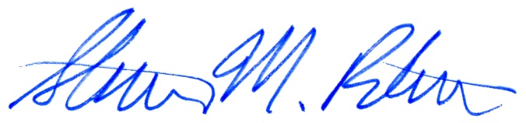
Steven M. Roberts, Architect, AIA, NCARB

1. Example of an integrated louver in a storefront window:
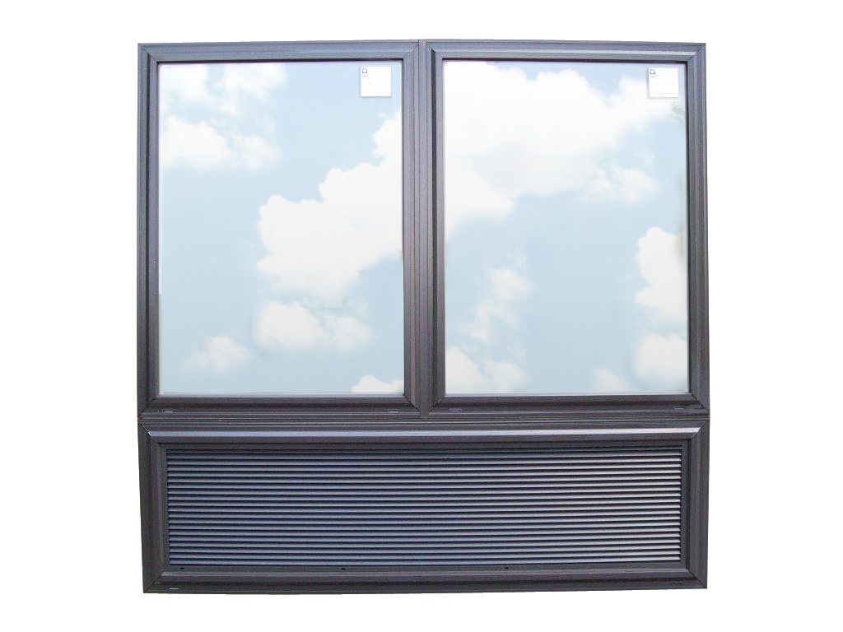

2 and 3. Example of an intake / exhaust louver at exterior brick wall painted to match. The example shown is 36” x 36” in size, while the TownePlace Suites ones will be 12” x 24” and 18” x 18”:

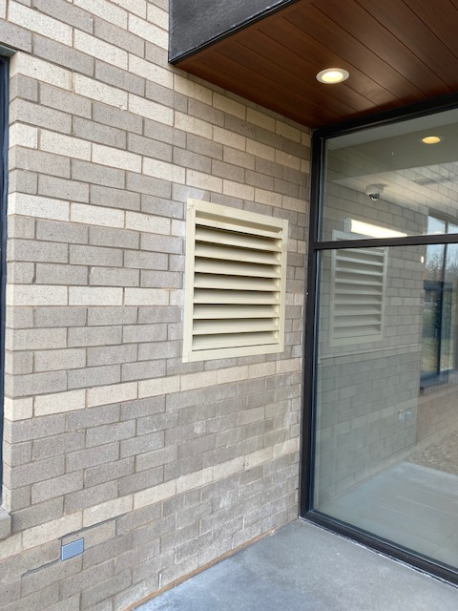

4. Example of a commercial gas meter:

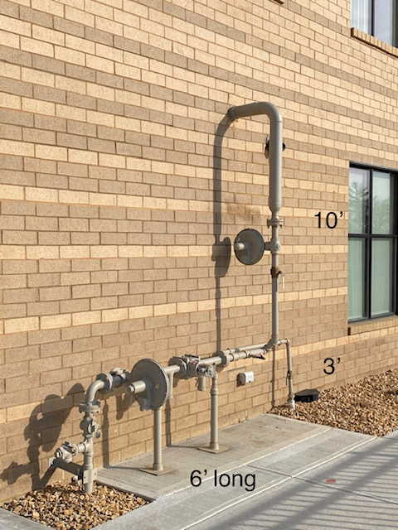

5. Example of an air intake grille 8” x 8” (will be painted to match adjacent brick color):

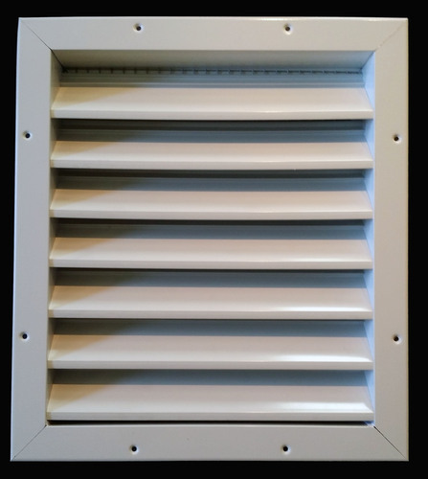

6, 7, and 8. Example of 8” x 8” metal exhaust grille with gravity flaps (will be painted to match adjacent brick color)

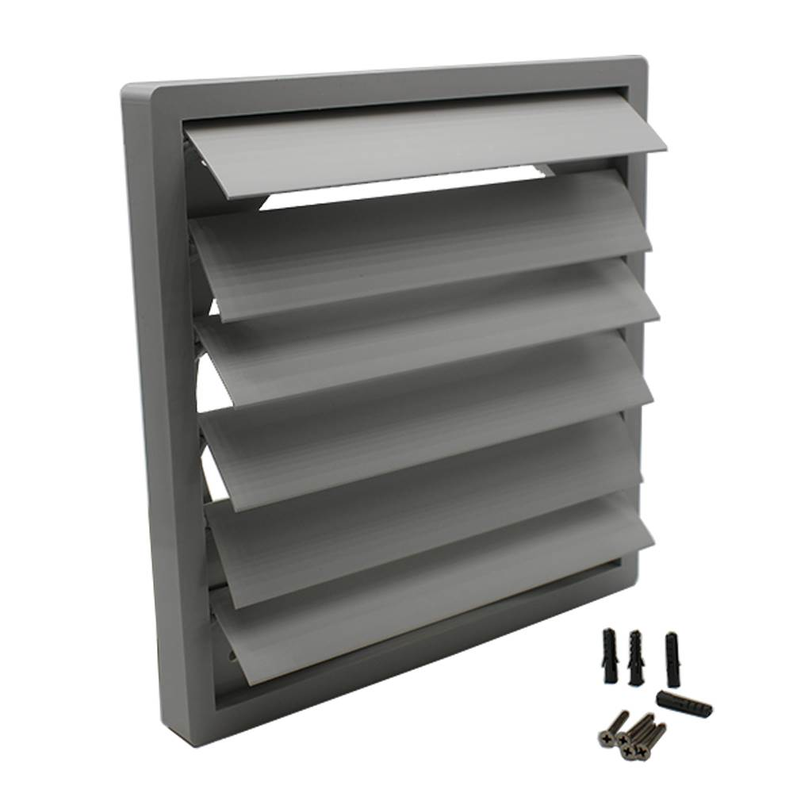

9 and 10. Example of concentric vents on an exterior brick wall. While these examples are not painted the TownePlace ones will be painted to match the adjacent brick color:

- Example of a brass roof overflow drain (“cow tongue”) on brick exterior:

