MEETING NOTES

Historic Dublin Task Force

Tuesday, August 4, 2020 | Live-Stream 4:00 pm

Historic Dublin Task Force Members Present: Kathy Lannan, Clay Rose, Garrick Daft, Burt Dowden, Kim Way, Carol Matune, Ed Ostrowski, Craig Price, Lynn Long, Alan Szuter, and Olivia Wirth.

HDTF Members Absent: Sally Van Horn, Jay Nordenbrock, Enas Lanham, Becky Brightman, Paula Yonnotti-Ansel, Mary Szuter, and Rohan Madan.

City Council and Dublin Staff: Jennifer Rauch, Planning Director; Tammy Noble, Senior Planner; Devayani Puranik, Senior Planner; Sara O’Malley, Economic Development Administrator; Laurie Wright, Administrative Support II; and Kyle McKee (moderator).

Ms. Rauch welcomed everyone to the virtual meeting and thanked them for their participation. She said the Task Force would meet bi-monthly on Tuesdays from 4 pm to 6 pm and the virtual meeting protocol will be followed until instructed otherwise.

Ms. Noble thanked the members for their participation in this Task Force and said staff is looking forward to working with all of them in the upcoming months. She said each and every one of you have been appointed to provide a unique perspective of the Historic District and all thoughts are welcome. She provided a background of the Task Force:

- City Council established the Task Force (Res 57-19) and appointed members that represented various interests in the District.
- This grass root effort is for the members of the Task Force to provide recommendations to City Council; not staff.
- Meetings started at the beginning of 2020 and culminated in a visit from Heritage Ohio.
- Meetings were briefly discontinued in early March, due to the pandemic and resumed July 21st.
- Meetings are intended to extend into September 2020 (or longer, if needed) and will result in final recommendations to City Council.

Ms. Noble said City Council assigned the Task Force to:

- Update the Historic District Area Plan that was originally adopted in 2007 and was incorporated into the Bridge Street District upon its adoption;
- Revisit the Community Plan and the Special Area Plan from time to time to ensure they are compatible with the City’s desired outcomes; and
- Determine the appropriateness of the Historic District being incorporated in the BSD.

Ms. Noble provided an over view of the Community Plan, Special Area Plans, and Zoning Districts/map as used in the planning process.

Ms. Noble compared the 2007 Historic District Area Plan to the Comments from the Task Force thus far:

Area Plan - Establish a new central focal point and unique gateway features.
HDTF Comment - Gateways to HD are not yet memorable.

Area Plan - Enhance the quality streetscape environment in the District.
HDTF Comments:
- Consider a boulevard effect;
- Provide more seating opportunities and community areas for gathering;
- Encourage more of a community feel with pedestrians and bikers;
- Provide traffic control to decrease speeding; and
- Experiment with bump outs for parking vignettes to slow traffic and create more planting areas.

Area Plan - Increase safe vehicular and pedestrian choices
HDTF Comments:
- Consider the safety of pedestrians in roundabouts (SR 161/Riverside Dr.); and
- Provide easy bike access.

Area Plan – Encourage shared parking and clear wayfinding
HDTF Comments:
  - Ensure the area is not consumed by parking;
  - Ensure parking does not overwhelm the district; but
  - Love the new wayfinding signs directing people to various sites.

Area Plan – Enhance the mixed-use and civic nature of the Historic District
HDTF Comments:
- Support mixed-use development so people can live/work in close proximity;
- Allow residential areas to mix with commercial areas;
- Focus on educational experiences with HD connections; and
- Provide sufficient civic uses.

Area Plan – Establish clearly defined parks and open spaces
HDTF Comments:
- Respect natural corridors;
- Provide more access to the Scioto River and with better signage ;
- Connect park access along the river up N. High Street; and
- Provide a clearer connection/access to Kiwanis Park access.

Ms. Noble concluded that comments received from public input sessions formulate recommendations that lead to implementation strategies. Recommendations have included the following:

- Mixed-use infill development;
- Full-paver intersection treatments to signify main intersections;
- Future public river access and park amenities;
- Integration of multi-story residential units overlooking the river;
- Targeted commercial infill to enhance streetscape edge; and
- Adaptive reuse for high-end residential condos overlooking river.
Ms. Noble shared several new themes the Task Force has discussed that may lead to future recommendations:

- Proper oversight of the District is needed (potential for Heritage Ohio or other entity);
- Process improvement for business owners;
- Encourage/improve economic vitality of the area;
- Exploring options for mobility (shuttles, bike share program, etc);
- Encourage activity in the district through events; and
- Historic preservation.

Ms. Rauch led the mapping exercise. First the Task Force comments and highlighted themes were discussed.
They used the themes to illustrate examples of comments on a map, which it correlated to.

Ms. Rauch began with streetscapes and wayfinding – prompting feedback for areas for improvement. Ms. Puranik provided notes that correlated with a marker on the map. The map is located on the City’s website to be found with this link: https://dublinohio.maps.arcgis.com/apps/webappviewer/index.html?id=09bd467e492e4a0589feeab6858bc580

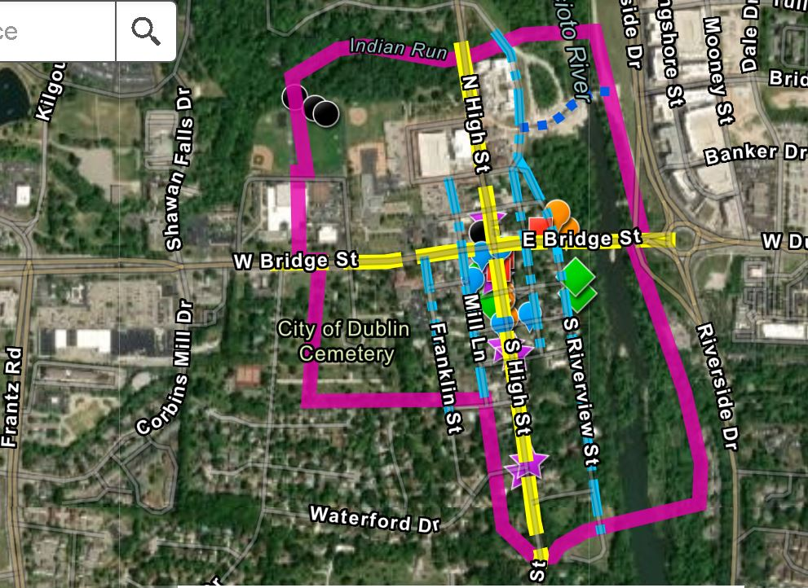

You may zoom in on the map to see more of the markers as below:

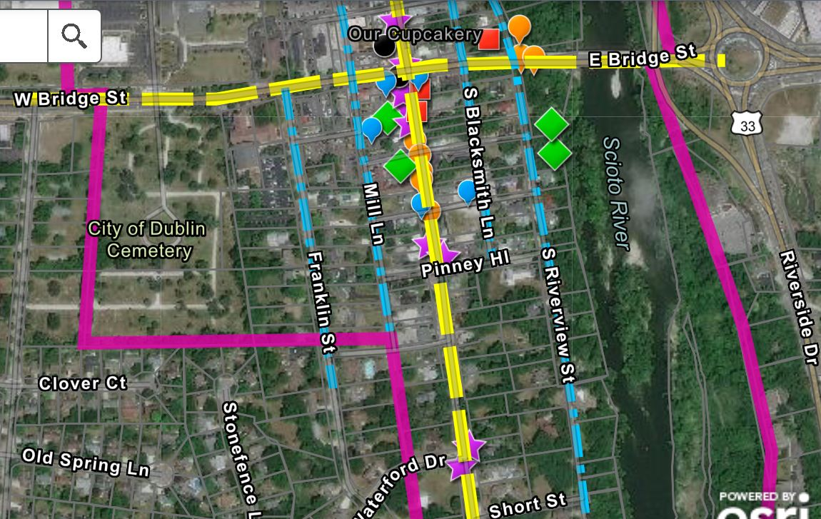

Zoom in closer to distinguish each marker. Click on the marker and it will state the improvement the HDTF suggested for that specific area:
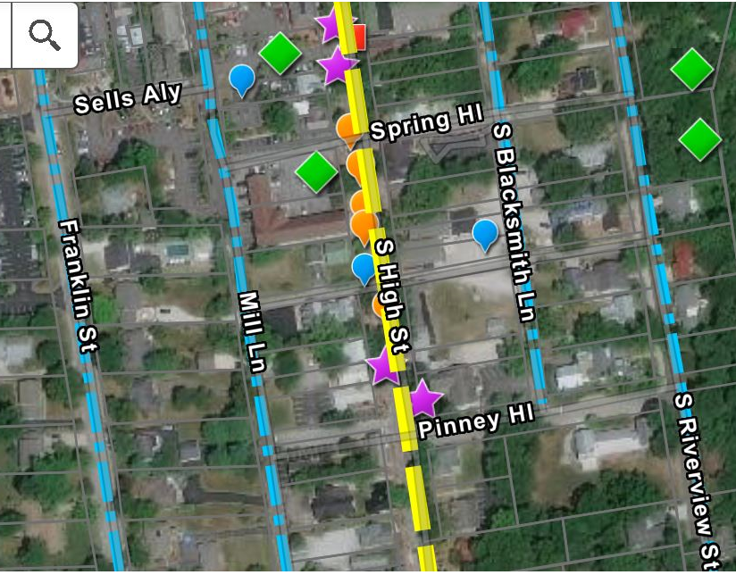
LEGEND
Magenta line is perimeter of Historic Dublin.
Blue dot and dash lines = Secondary Corridors
Yellow dash lines = Primary Corridors

Orange Balloon = Streetscape and Public Art
Blue Balloon = Parking and Wayfinding
Green Diamond = Open Space and Natural Corridor Connectivity
Red Square = Architecture and Historic Preservation
Purple Star = Programming and Management
Black Circle = Land Uses

HDTF comments - Streetscape and Public Art:
- Bury Utilities
- Preserve and Enhance Trees
- Widen Sidewalks and Tree Boxes
- Appropriate Street Lights for S. High St.
- Common Themes for Building Exterior Lighting
- Lighted Paths
- Connect South and North for Pedestrians
- Current Issue –Steep Grade and Parking
HDTF comments - Parking and Wayfinding:
- Shared Parking Opportunities with Private Owners
- Do Not Add Any More Parking Lots
- Encourage Alternative Transportation
- Signs to Direct to Parking
- Subset of Sign Designs Specific for Historic Dublin

HDTF comments - Open Space and Natural Corridor Connectivity:
- Enhance Parking with Planters/Seating
- Preservation and Enhancements to Existing Parks
- Preserve Parks and Indian Run as Assets

HDTF comments - Architecture and Historic Preservation:
- Area of Concern for Historic Preservation
- Conversation Regarding Historic Preservation within the District
- Explore an Employee or Group Helping Property Owners to Help Preserve Properties Including Grants

HDTF comments - Programming and Management:
- Potential Music Events
- Consider Closing Streets for Events like the Art Festival
- Design and Plan High Street for Events
- Alternate Between N and S High Street for Events
- Make Gathering Space for Events, which Should Happen Periodically
- Explore Historic Side of Dublin via an App
- Historic Dublin App with all HD Information like Parking, Parks, etc.
- Historic Dublin Tour via App with the Historical Society
- Historic Plaques for Historic Homes

HDTF comments - Land Use:
- HD Boundary Should Include Indian Run Falls
- No High-end Condominiums or Residential, Preserve Indian Run
- Apply and Implement Guidelines to HD to Preserve the District
- Protect and Preserve Parks with the Right Setbacks and Buffers and Follow Historic Dublin District Guidelines
- Conduct Potential Discussion with the Architectural Review Board members

Ms. Rauch stated the next meeting is on Tuesday, August 18 at 4 pm to 6 pm, live-streamed on YouTube. She adjourned the meeting at 6:00 pm.

